Chapter 5 - SMO Studio Architecture

5.1. Overview

The SMO Studio is a computational lithography simulator that co-designs the illumination pupil (DOE, or Diffractive Optical Element) and the photomask (OPC, Optical Proximity Correction) so that a target pattern prints on the wafer with minimum edge error.

- The system models a 193 nm dry ArF exposure tool with numerical aperture NA = 0.85 and 4× reduction.
- At the fast-resolution grid one mask pixel corresponds to 31.25 nm at the reticle plane and 7.8125 nm at the wafer plane;
- The Rayleigh limit k₁·λ/NA gives a resolvable half-pitch of 113 nm at wafer for k₁ = 0.5, which places the 60 nm-CD contacts in our target library well below the "easy" print regime — exactly the regime that requires off-axis illumination and mask correction.

The Studio implements the classical Abbe partial-coherence forward model, wraps it in an alternating gradient-descent optimizer over the mask and source, and applies manufacturability projections (Mask Rule Check on the mask, binary-aperture projection on the source) so that the final artifacts match what a real mask shop and illuminator could deliver.

5.2. The Abbe Forward Model

Abbe's decomposition treats a partially coherent illumination system as an incoherent sum over independent source points. Each source point at normalized pupil coordinates (kₓ, k_y) illuminates the mask with a tilted plane wave and produces a coherent aerial image at the wafer; the total intensity is the weighted sum

I(x, y) = Σₖ wₖ · |Eₖ(x, y)|² with Σₖ wₖ = 1

where,

- the sum runs over all P sampled source points,
- wₖ is the relative brightness of point k, and
- Eₖ is the complex aerial field for that point.

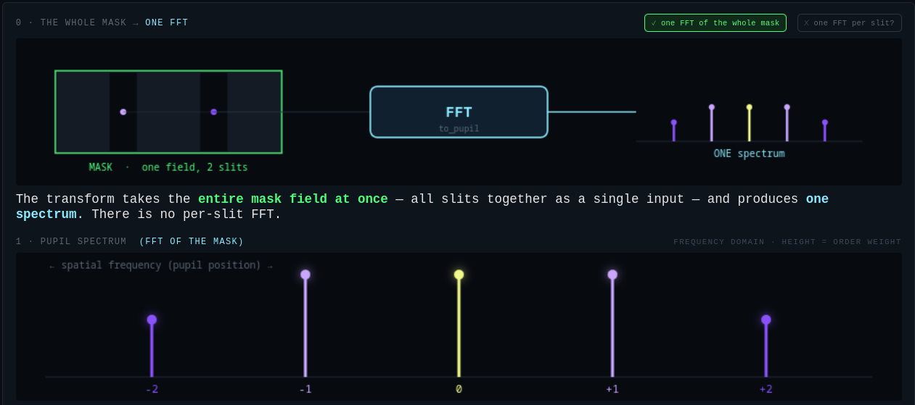

The whole mask has one FFT. The FFT does not represent the diffration pattern of each individual element. This is what makes the Abbe principle scalable to large reticles

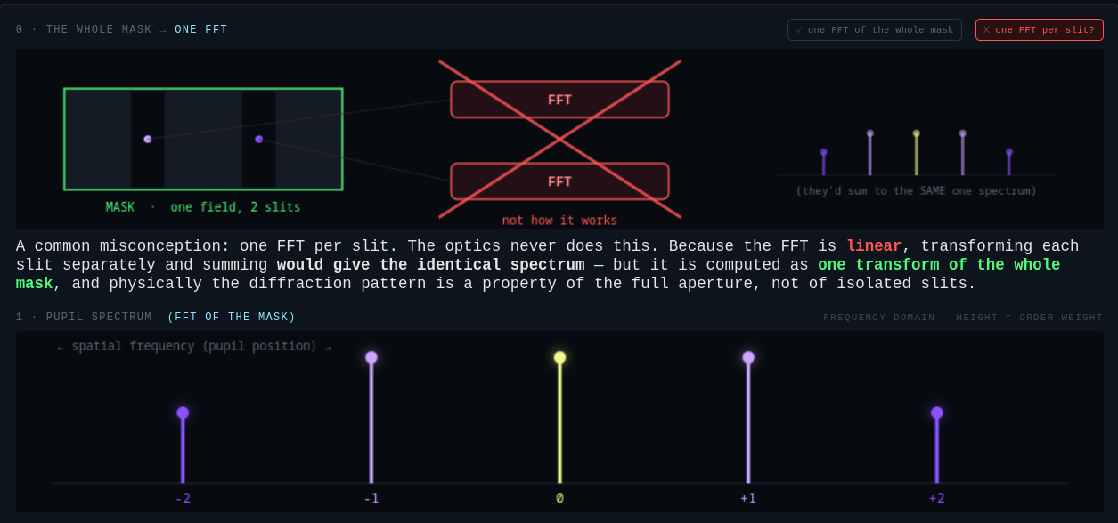

The Studio computes each Eₖ by threading three physical operators:

Eₖ = ProjectionLens( Reticle( Illuminator(1; kₓ, k_y) · m ) )

The works by modelling the DUV pipeline elements in the order they are arranged in the path of the 193nm DUV later.

- The illuminator imprints the (kₓ, k_y) tilt on an initially uniform field,
- Reticle multiplies the tilted field by the mask transmission m(x, y),
- ProjectionLens applies the band-limited 4×-reduction lens.
- The wafer recieved the final intensity pattern

The printed resist pattern is obtained by passing the aerial intensity through a smooth threshold that approximates chemically-amplified-resist behavior:

z(x, y) = σ( s · [ I(x, y) / I_open − t ] )

where
- σ is a logistic sigmoid,
- s = 8 is the resist steepness,
- t = 0.30 is the exposure threshold, and
- I_open is the intensity at an open-frame (fully clear) mask position, used to normalize the exposure dose.

The sigmoid keeps z differentiable in I everywhere, which is what makes the whole pipeline compatible with gradient descent. This is because gradient decent needs a differentiable function and the derivative of a step function is 0.

5.3 FFT / IFFT and the Projection System

The propagation between the real-space plane and the pupil (spatial-frequency) plane is a discrete Fourier transform. The Studio uses the forward transform

F(kₓ, k_y) = Σₓ Σ_y f(x, y) · exp( −2πi (kₓ x + k_y y) / N )

and its inverse

f(x, y) = (1 / N²) · Σₖₓ Σₖ_y F(kₓ, k_y) · exp( +2πi (kₓ x + k_y y) / N )

These are wrapped in helpers

- to_pupil() and
- to_real()

that apply the correct fftshift / ifftshift on both sides and rescale for the physical pixel size dx_reticle so the pupil-plane coordinates come out in cycles per metre.

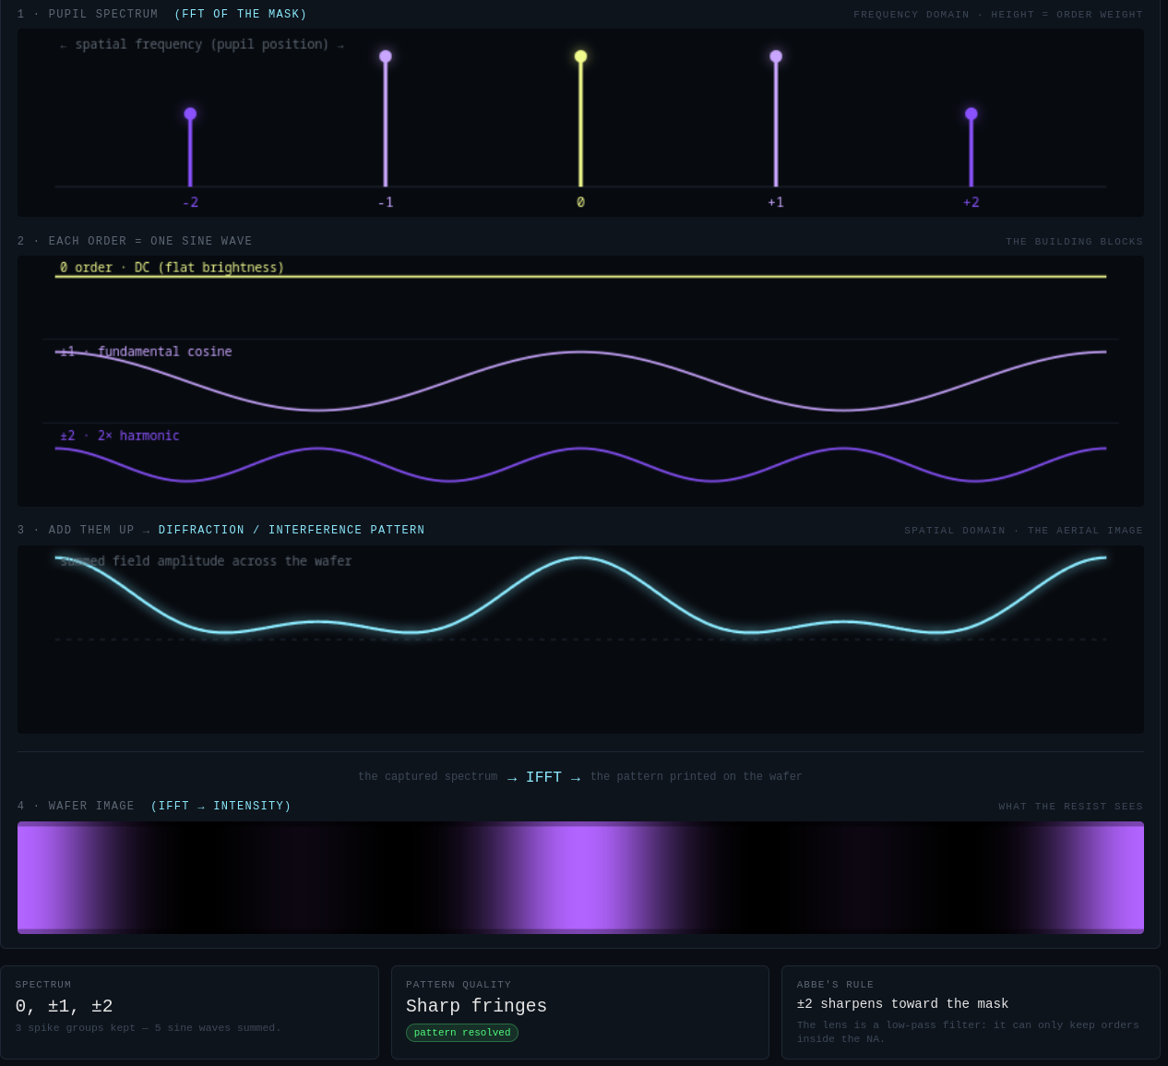

The projection lens is a three-step operator. It forward-transforms the incoming field to the pupil plane, multiplies by a hard binary aperture P(kₓ, k_y) that passes only spatial frequencies inside a disc of radius NA · M_reduction / λ (any frequency outside the pupil is set to zero), and inverse-transforms back to the real plane.

This is the standard diffraction-limited low-pass filter: features finer than the Rayleigh half-pitch cannot pass through the lens, no matter what mask you write. All optical resolution comes from the interplay of the mask spectrum and this pupil.

5.4 Loss Function

The optimizer minimizes a mean-squared-error loss between the printed pattern z and the desired binary target T, both evaluated on the wafer grid:

L(z, T) = (1 / N²) · Σₓ Σ_y ( z(x, y) − T(x, y) )²

The gradient of L with respect to the aerial intensity I follows from the chain rule through the resist sigmoid,

∂L/∂I = ∂L/∂z · ∂z/∂I = (2 / N²) · ( z − T ) · s · z · (1 − z) / I_open

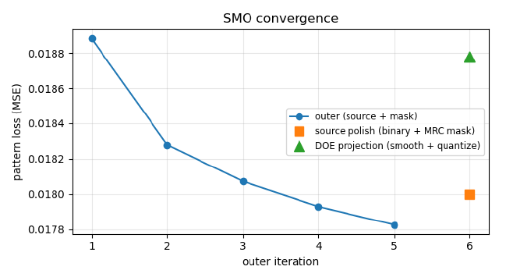

The factor z · (1 − z) vanishes wherever z is saturated at 0 or 1 and peaks around z = ½ — that is, the loss only "notices" pixels sitting on the edge of a printed feature, precisely the regions OPC needs to correct.

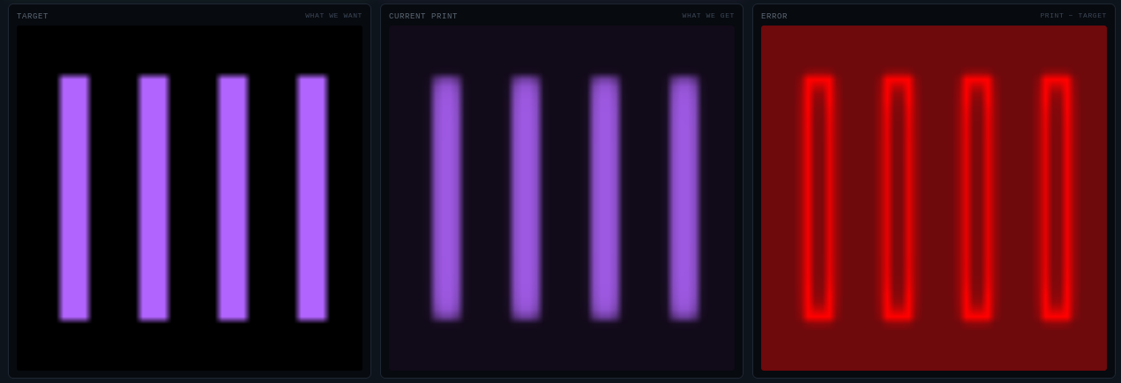

The Studio also reports a manufacturability-facing metric, edge_px, which counts wafer pixels whose printed value falls on the wrong side of the target boundary.

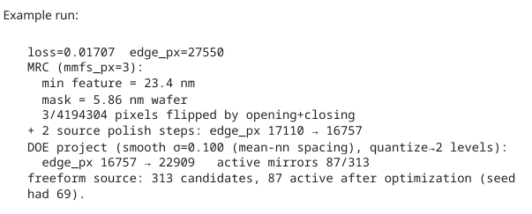

The all-pupils sweep runner ranks candidate starting pupils by their final edge_px because that number is closer to what a mask-shop engineer would care about.

5.5 Gradient-Descent Architecture

The engine uses an alternating scheme: each outer iteration applies (A) a mask update with the source held fixed, then (B) a source update with the mask held fixed. This is the standard SMO structure and factors a hard joint problem into two easier sub-problems that share one common forward model.

5.5.1 Mask gradient (ILT adjoint).

For each source point k, the coherent-image contribution is Iₖ = |hₖ · m|² where hₖ is the effective coherent transfer for that source point. The Poonawala–Milne adjoint identity gives

∂Iₖ / ∂m = 2 · Re { conj(incidentₖ) · adjointₖ }

where the "adjoint field" is obtained by back-propagating the loss-shaped gradient of Iₖ through the projection lens. Summing over source points weighted by wₖ gives the total mask gradient ∂L/∂m. To keep the mask in the physically meaningful [0, 1] range without a projection step, the Studio parameterizes it as m = σ(θ) for an unconstrained variable θ; the chain rule gives

∂L/∂θ = ∂L/∂m · σ(θ) · (1 − σ(θ)).

5.5.2 Straight-through estimator for binary masks.

Real chrome-on-glass masks are strict binary. The Studio uses a straight-through estimator (Bengio & Courville, 2013): the forward pass always uses the hard-thresholded mask

m = ퟙ{ σ(θ) > 0.5 } ∈ {0, 1},

so every gradient step is evaluated on exactly the mask that will be delivered, while the backward pass pretends the θ→m transfer is still the smooth sigmoid so

dm/dθ = σ(θ) · (1 − σ(θ)) never vanishes.

This lets a pixel that has already committed to one rail flip back later if that would improve the print, and it eliminates the discontinuous quality drop that a naive "solve continuous, threshold at end" strategy produces. This allows us to implement freeform DOE pupils.

5.5.3 Source gradient.

The aerial intensity is linear in the source weights, I = Σₖ wₖ · Iₖ(m), so the gradient is a simple projection

∂L/∂wₖ = Σₓ Σ_y ( ∂L/∂I ) · Iₖ(x, y)

which requires only one coherent image per source point per source-step iteration — an order of magnitude cheaper than the mask step.

Weights are then updated multiplicatively,

wₖ ← wₖ · exp(−½ · gₖ / max|g|),

which preserves positivity automatically, and are renormalized so Σₖ wₖ = 1 remains a valid pupil.

5.5.4 Update rule.

The mask update is

θ ← θ − η · g_θ / max|g_θ| with default learning rate η = 0.4; t

he normalization by the peak gradient keeps the θ-space step size bounded regardless of the absolute loss scale, so no learning-rate retuning is needed as the target pattern or resolution changes.

The default outer loop runs 5 iterations, each with 12 inner mask sub-steps and 1 inner source sub-step.

The asymmetry between 12 and 1 reflects the underlying dimensionality: the mask has ~262,000 pixels to fit while the source has only 4 to a few thousand points, so the mask needs more inner iterations per outer to converge to its own optimum given the current source.

5. 6. Manufacturability Projections
After the outer loop converges the Studio runs two projections that make the artifacts realizable on real hardware.

5.6.1 Mask Rule Check. A morphological opening followed by a closing, both at kernel size mmfs_px × mmfs_px (default 3, corresponding to a 94 nm minimum mask feature at 31.25 nm/px), removes any clear feature or gap narrower than the mask writer's minimum feature size and fills sub-MMFS chrome specks. A short source-only polish then lets the DOE adapt to the cleaned mask, absorbing most of the edge-error jump the cleanup introduces.

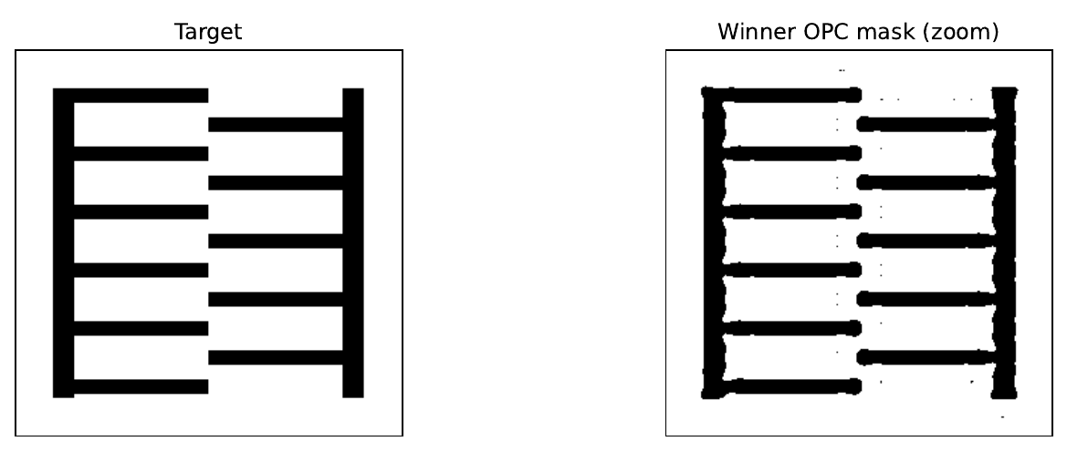

5.6.2 Binary-aperture DOE projection. The polished source is first smoothed in pupil space with a Gaussian at σ equal to the mean nearest-neighbor spacing (kills isolated single-point spikes while preserving large-scale poles) and then quantized to 2 levels — a strict binary aperture in which each pupil region is either fully lit or fully dark and total power divides equally among the lit regions. This is the most conservative physically-realizable model and requires no assumption of programmable mirror hardware. Setting source_levels = 6 recovers a multi-level output appropriate for a FlexRay-class mirror-array illuminator, where multiple levels represent multiple mirrors pointing to the same pupil region rather than intensity variation of the laser (the laser is uniform).

5. 7 Summary

The SMO Studio implements the classical Abbe / Poonawala–Milne computational-lithography pipeline with a modern binary-mask straight-through estimator and physically-honest manufacturability projections. The forward model computes an aerial image by summing coherent contributions from each source point — each an FFT-based projection through a band-limited pupil — and a differentiable resist sigmoid converts intensity to a printed pattern. A mean-squared-error loss drives gradient descent alternately over the mask pixels and source weights, and post-loop MRC and binary-aperture projections leave the pipeline outputting a strict-binary chrome-on-glass mask and an aperture-realizable DOE that together minimize edge error on the target — as close to what an actual dry-193 nm exposure tool with a real mask shop behind it could deliver as the model allows.

